Software Requirements Specification (SRS)
For: Aegis ID – Your Secure Digital Campus Pass
Prepared by:
- Kavyan Hembrom (IIT2024245) – UI/UX Design & Wireframe Design
- Afzal Raja (IIB2024031) – Backend Developer
- Abdul Azeem (IIT202423) – User Schema Development
- Khushi Shorey (IIT2024244) – Basic Backend Support
- Vandita Jain (IIT2024228) – Frontend Developer
- Shon Ravindra Waghchoure (IIT2024247) – Blockchain & Security
Date: 07/09/2025
Course: CS301 – Software Engineering
Institute: Indian Institute of Information Technology, Allahabad

1. Introduction

1.1 Purpose
- Create a secure, efficient, and user-friendly digital identity platform for students.
- Address inefficiencies of manual sign-ins and reduce risks of static physical IDs.
- Integrate emergency support within the campus ecosystem.
1.2 Scope
In Scope: Digital campus ID, dynamic encrypted passkey generation, QR/NFC-based access, hostel outpass management, emergency call with location sharing.
Out of Scope: Offline operation without connectivity, direct integration with government ID systems.

1.3 Definitions, Acronyms, and Abbreviations
- SRS – Software Requirement Specification
- JWT – JSON Web Token
- NFC – Near Field Communication
- SHA-256 – Secure Hash Algorithm (cryptographic hash)
- Aegis ID – Proposed digital campus pass system

1.4 References
- IEEE SRS 830–1998 Structure
- Internal team notes and project proposal

1.5 Overview
This document describes features, interfaces, data design, architecture, security, workflows, and constraints of the Aegis ID application.

2. Overall Description

2.1 Product Perspective
- Mobile-first standalone system
- Backend API integration
- QR/NFC gate scanners
- Authentication services
- Optional blockchain ledger for audit logs

2.2 Product Functions
- Daily passkey generation (QR/NFC) with time-based expiry
- Non-sharable passkeys (screenshot prevention, device binding)
- Outpass management (request, approval, tracking)
- Emergency services (one-tap call, location sharing)
- Profile management (students, admins, wardens, security)

2.3 User Classes and Characteristics
- Students: Generate/scan passkeys, request outpass, trigger emergency.
- Wardens: Approve/reject outpass requests.
- Security Staff: Validate passkeys, handle emergencies.
- Administrators: Manage users, policies, and audit logs.

2.4 Operating Environment
- Mobile app: Android (React Native)
- Backend: Node.js/Express, MongoDB
- Secure HTTPS communication
- NFC hardware and camera-based QR scanning

2.5 Design and Implementation Constraints
- Variable campus connectivity
- NFC hardware differences
- Privacy regulations (data & location)
- Peak-hour throughput at gates
- Need for scalable and secure infrastructure

2.6 Assumptions and Dependencies
- Students own smartphones with internet access
- QR/NFC scanners are available at gates
- Backend and database services remain operational

3. Specific Requirements

3.1 Functional Requirements
FR-01 Daily Passkey Generation
- Generate encrypted, time-bound, device-bound QR/NFC token.
FR-02 Secure Passkey
- Prevent screenshots, bind token to registered device ID.
FR-03 Scan & Go / NFC Access
- Validate passkeys via QR scan or NFC tap.
FR-04 Outpass Management
- Student submits request → Warden approves/rejects → Notification sent.
FR-05 Emergency Services
- One-tap call to security/ambulance with GPS auto-share.
FR-06 Profile Management
- Student can update info; Admins manage roles.

3.2 External Interface Requirements
User Interfaces
- Login/Registration: Email/Student ID, password

- Dashboard: Generate Passkey, Scan QR, Request Outpass, Emergency Help

- QR/NFC Passkey: Dynamic QR display, countdown/expiry indicator

- Outpass Request: Form (date, time, reason), status tracking

- Emergency: Call security/ambulance, show location

- Profile: View/edit details, device binding info
Hardware Interfaces
- NFC readers, QR scanners, mobile device camera/NFC chip
Software Interfaces
- React Native app ↔ Express.js APIs ↔ MongoDB/Firebase
- Notification/SMS integration
Communications Interfaces
- HTTPS/TLS 1.2+
- JWT-based request authorization
- JSON payloads

3.3 Non-Functional Requirements
- Security: JWT, bcrypt, SHA-256, role-based access, blockchain logs
- Performance: <300ms validation p95, scalable caching, horizontal scaling
- Availability: 99.5%+ during term time, graceful degradation (fallback QR if NFC unavailable)
- Usability: Accessible UI, offline-friendly states
- Maintainability: Modular services, documented APIs, CI/CD pipelines
- Privacy: Minimal data retention, explicit consent for location sharing, encryption at rest & in transit

4. System Features
(Detailed use cases already mapped in Section 5.7)
- UC-01 Generate Passkey
- UC-02 Validate Passkey
- UC-03 Request Outpass
- UC-04 Emergency Alert

5. Other Requirements

5.1 System Architecture & Technology Stack

Mobile: React Native

Backend: Node.js/Express

Database: MongoDB

Security: JWT, bcrypt, SHA-256, CORS, validation

Hardware: NFC + QR libraries

5.2 Database Design

Collections: Students, Passkeys, OutpassRequests, EmergencyLogs, BlockchainLogs

Relationships: Student ↔ Passkeys/Outpass/Emergency/Blockchain (1:M)

Schemas: Provided in Appendix C

5.3 API Structure

The backend is organized into modular Express.js route files, each handling a specific domain:

authRoutes.js – Handles user authentication (register, login, logout, token refresh)

studentRoutes.js – Manages student-specific actions (profile, passkey generation, outpass requests)

adminRoutes.js – Provides administrative controls (user management, audit logs, system settings)

securityRoutes.js – Used by campus security staff for passkey validation, emergency alerts, and access logs

passkeyRoutes.js – Endpoints for generating, validating, and revoking passkeys

outpassRoutes.js – Handles outpass request submission, approval/rejection, and status tracking

emergencyRoutes.js – Manages emergency alert creation, status updates, and responder actions

5.4 Workflows

Outpass Request: Student → API → Warden → Student notified

Passkey Validation: Student → Generate → Scan → Server validate → Access

Emergency Alert: Student triggers → GPS logged → Security notified

5.5 Security Measures

JWT authentication + refresh flow

Bcrypt password hashing

SHA-256 key derivation + device binding

HTTPS, input validation, rate limiting

Audit logs (optionally blockchain-backed)

5.6 Constraints & Risks

Device loss/theft (mitigate with re-binding, revoke)

Connectivity outage (fallback QR, retries)

Privacy issues (mitigate with consent, minimization)

5.7 Use Cases (Descriptive)

UC-01 Generate Passkey

Actor: Student

Precondition: Authenticated; device registered

Main Flow: Student taps Generate → System creates time-bound token → Display QR/NFC

Postcondition: Passkey active until expiry or revoke

UC-02 Validate Passkey at Gate

Actor: Security Staff

Precondition: Passkey valid; network available

Main Flow: Scan QR / read NFC → Server validates → Show result

Alternate: Token expired/device mismatch → Deny access; log incident

UC-03 Request Outpass

Actor: Student

Main Flow: Fill form → Submit → Status Pending → Warden Approves/Rejects → Student notified

UC-04 Emergency Alert

Actor: Student/Security

Main Flow: Tap emergency → GPS captured → Alerts sent → Responders track status

5.8 Frontend Design Layout & Tools

Primary Framework: React Native

Design Tool: Figma

Login/Registration: Email/Student ID & Password

Dashboard: Generate Passkey, Scan QR, Request Outpass, Emergency Help

QR/NFC Passkey: Dynamic code with expiry timer

Outpass Request: Date, time, reason; submit & status view

Emergency: Call Security/Ambulance; auto-location sharing

Profile: Student details; edit/account settings

Navigation Flow: Login → Dashboard → (Profile / Outpass / Passkey / Emergency)

5.8.1 Component Library

Reusable React Native components used throughout the application:

EmergencyButton.js – Button for triggering emergency actions (calls, alerts)

FilterTabs.js – Tabbed navigation for filtering lists or views (e.g., outpass status, room types)

LoadingSpinner.js – Animated spinner for indicating loading states

LocationCard.js – Card displaying location details (rooms, hostels, emergency info)

OutpassCard.js – Summarizes outpass requests, status, and actions

PasskeyCard.js – Displays the current passkey (QR/NFC), expiry, and device binding info

QuickStatsCard.js – Shows quick statistics (seat availability, issued books, user stats)

RoomCard.js – Displays room information, occupancy, and related actions

5.8.2 Context Providers

Global React Context modules for state management:

AuthContext.js – Authentication state, user info, login/logout actions

ThemeContext.js – Dark/light theme state and color palette

5.8.3 Screen Structure & Navigation

LoginScreen.js – Student ID + password login

RegisterScreen.js – Account creation

DashboardScreen.js – Main hub for passkeys, outpass, emergency help

ProfileScreen.js – Profile info, editing, device binding

LibraryScreen.js – Library statistics, seat availability, issued books

CreateOutpassScreen.js – Form for outpass request

OutpassScreen.js – List of requests with statuses, approval/rejection

EmergencyScreen.js – Call options, location sharing, incident status

LoadingScreen.js – Spinner during data fetch/transition

ScannerScreen.js – QR code scanning for passkey validation

SACScreen.js – Student Activity Center events and info

5.9 Backend Design & Tools

5.9.1 Middleware Modules

auth.js: Verifies JWT tokens, authenticates users, attaches user info

adminAuth.js: Restricts access to admin-only routes, checks role

outpassExpiry.js: Blocks actions on expired requests

5.9.2 Runtime & Tools

Runtime: Node.js

Framework: Express.js

Database: MongoDB

Auth: JWT

Optional: Firebase & Blockchain layer

Authentication Process:

User enters Email + Password

Server verifies credentials (MongoDB)

On success, generates short-lived JWT

Client uses JWT in Authorization header for subsequent requests

5.10 Data Flow Architecture

Mobile App (React Native)
↓ HTTP(S) REST APIs
↓ Express.js Server
↓ MongoDB Database
↓ Optional Blockchain Logging

Notifications to wardens/security via push/SMS

Audit logs retained per policy

5.11 Validation & Logging

All critical events (access attempts, approvals, emergency alerts) logged with timestamps and actor IDs

Validation checks include:

Token freshness

Device ID match

Role-based permissions

5.12 Constraints & Risks

Device loss/theft: Mitigated via re-binding and remote revoke

Connectivity outages: Mitigated via retries and local caching of QR display (server-side validation authoritative)

Privacy concerns: Addressed by minimization and explicit consent for location sharing

Appendixes

Appendix A – Sample Data Objects

Student: { student_id, name, email, hostel_id, device_id }

Passkey: { passkey_id, student_id, date, encrypted_key, expiry_time }

OutpassRequest: { request_id, student_id, reason, date, time, status, warden_id }

EmergencyLog: { emergency_id, student_id, type, timestamp, location, status, description }

Appendix B – Glossary

Device Binding: Association of user account with a specific device ID

Immutable Log: Tamper-evident record; optionally kept on blockchain

Passkey: Time-bound token representing digital campus access for the user

Appendix C – Model Schemas

User.js

const UserSchema = new mongoose.Schema({

name: { type: String, required: true },

studentId: { type: String, required: true, unique: true },

email: { type: String, required: true, unique: true },

passwordHash: { type: String, required: true },

hostelId: { type: String },

deviceId: { type: String },

role: { type: String, enum: ['student', 'warden', 'security', 'admin'], default: 'student' }

});

Passkey.js

const PasskeySchema = new mongoose.Schema({

studentId: { type: mongoose.Schema.Types.ObjectId, ref: 'User', required: true },

encryptedKey: { type: String, required: true },

date: { type: Date, required: true },

expiryTime: { type: Date, required: true },

deviceId: { type: String, required: true }

});

Outpass.js

const OutpassSchema = new mongoose.Schema({

studentId: { type: mongoose.Schema.Types.ObjectId, ref: 'User', required: true },

reason: { type: String, required: true },

date: { type: Date, required: true },

time: { type: String, required: true },

status: { type: String, enum: ['pending', 'approved', 'rejected'], default: 'pending' },

wardenId: { type: mongoose.Schema.Types.ObjectId, ref: 'User' },

createdAt: { type: Date, default: Date.now },

updatedAt: { type: Date, default: Date.now }

});

Emergency.js

const EmergencySchema = new mongoose.Schema({

studentId: { type: mongoose.Schema.Types.ObjectId, ref: 'User', required: true },

type: { type: String, required: true },

timestamp: { type: Date, default: Date.now },

location: { type: String },

status: { type: String, enum: ['active', 'resolved'], default: 'active' },

description: { type: String }

});

Log.js

const LogSchema = new mongoose.Schema({

studentId: { type: mongoose.Schema.Types.ObjectId, ref: 'User' },

eventType: { type: String, required: true },

hash: { type: String },

timestamp: { type: Date, default: Date.now },

previousHash: { type: String }

});

Approval & Sign-off

Prepared by: ____________________
Reviewed by: ____________________
Approved by: ____________________

USE CASE Diagram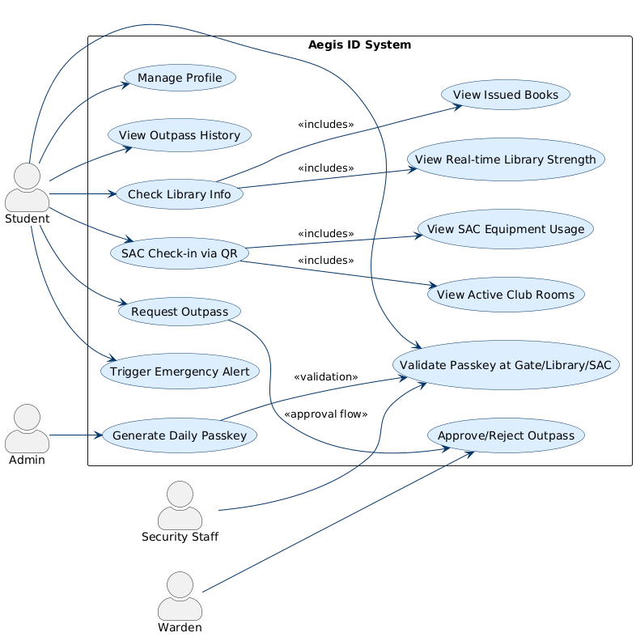

Activity Diagram
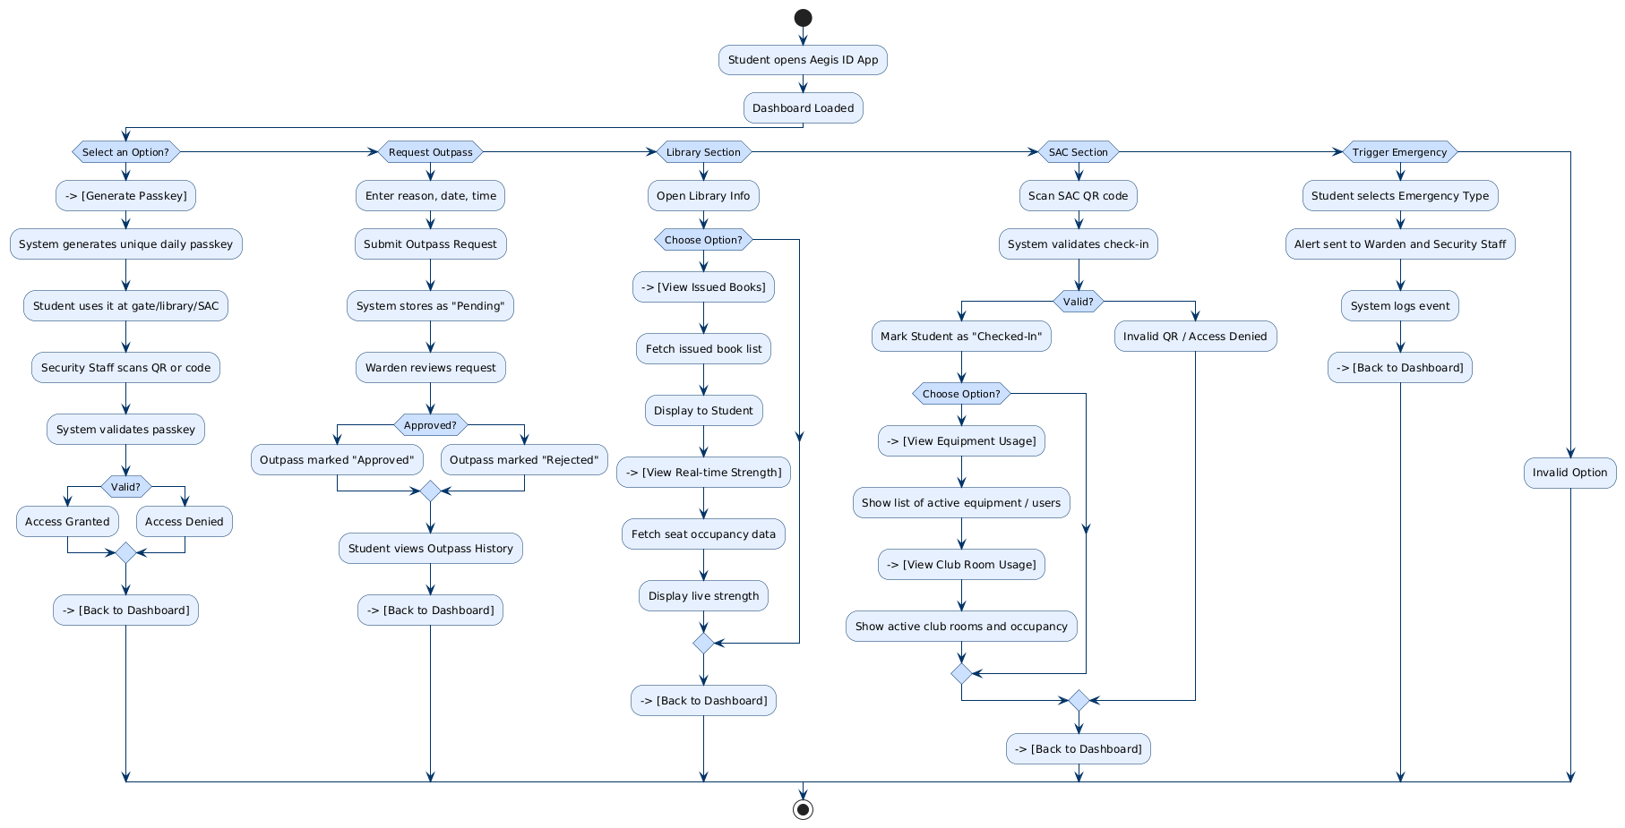

Sequence Diagram

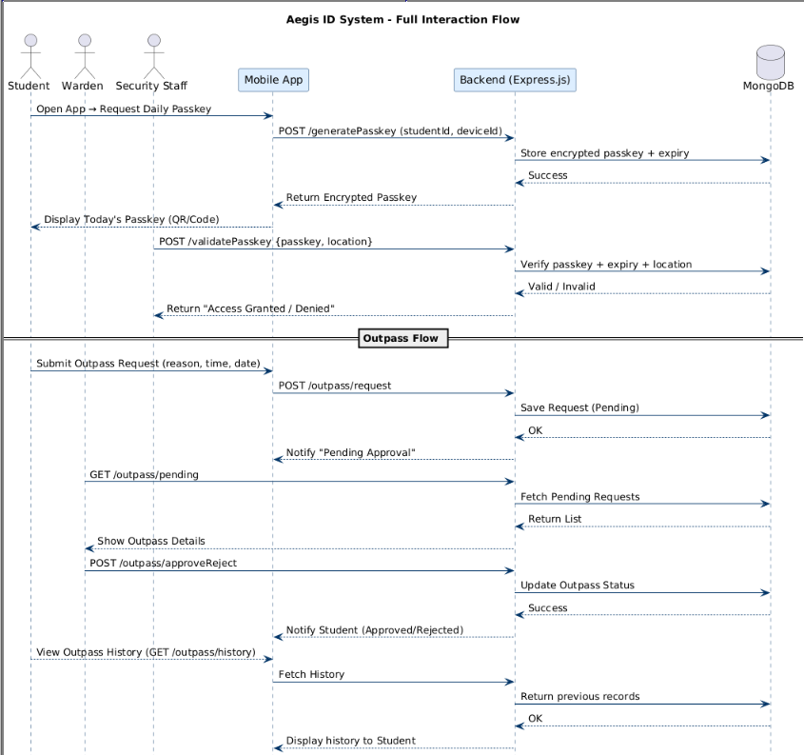

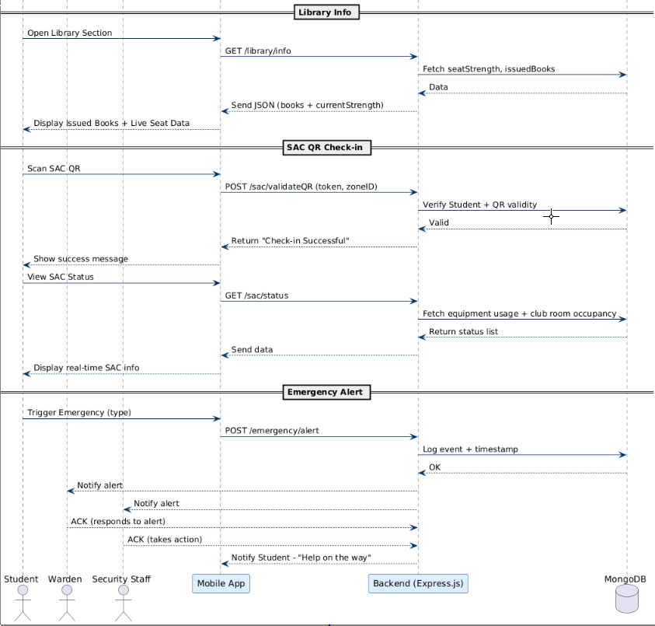
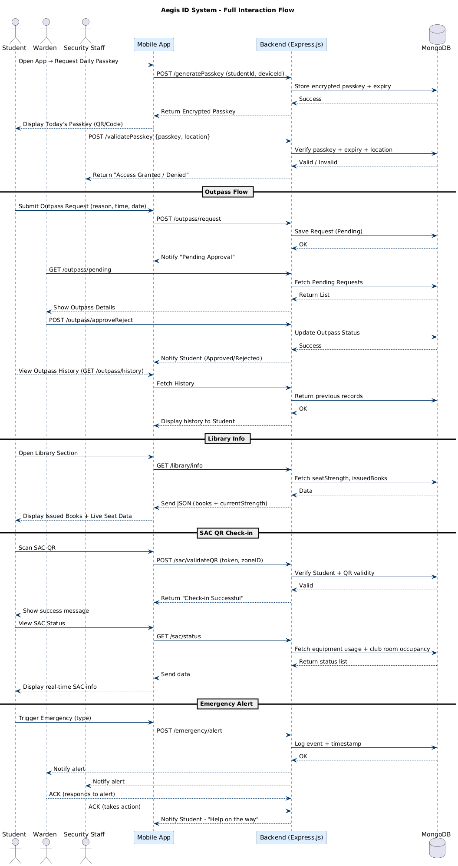

Class diagram
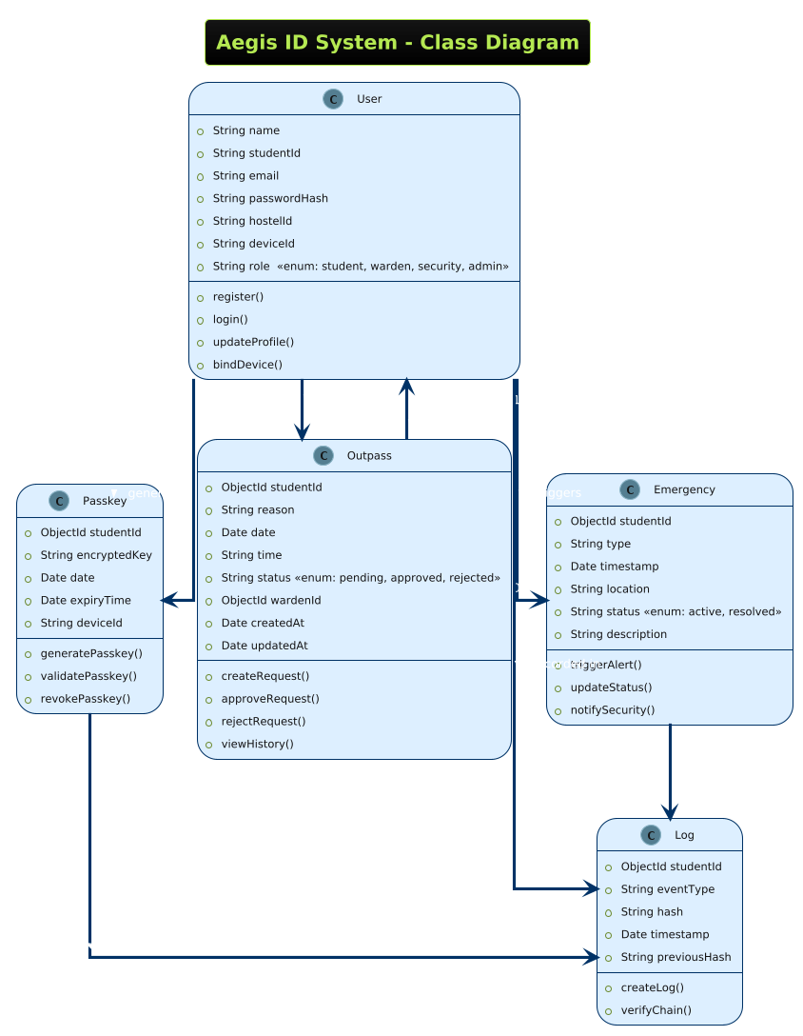

USECASE DIAGRAM

